Implementation of Secure RFID System for Protection of Classified Document Access in Agencies By
Performance Analysis of Pseudorandom Encryption Algorithms

SanjeevKumar , Dr. Haider Banka, Dr B Kaushik
sanjeevnarg@gmail.com, haider.banka@gmail.com bkaushik99@gmail.com

Abstract - An efficient light weight block cipher is necessary to achieve end-to-end security with the increase growth of IOT. So now-a-day Light weight cryptography is a recent research topic among researchers by preserving data integrity and security. In this paper we propose the performance analysis of five light weight protocols-SEAL, BLOWFISH, CLEFIA,RC5, GOST. Analysis of these protocols are evaluated by the parameters like throughput, encryption time, execution time ,decryption time and execution time. All of these parameter are evaluated on tested on different Plaintext Key sizes 16bits,32bits,64bits,128bits,256bits,512bits,1024bits,2048bits.A compara -tive analysis is performed by analysis of result based on these parameters
Keywords – IoT Security, Lightweight Cryptography, STM32F401 MCU.

- INTRODUCTION

.RFIDs are class of contactless devices having two fundamental constituent units:-the Reader and the Tag. The System operates in RF (Radio Frequency domain and in particular in UHF and LF bands. While the reader is a stationary unit and the tags are normally mobile. The two units communicate to each other through inductive coupling and back scattering in normal scenario. The tags have some predefined (and usually limited) memory space organized in form of structured blocks. The memory space used to store the tag data as well as user’s specified data as EPC for format. The reader which is usually self powered device interrogates the tag via a modulated interrogation message, if the tag is within the RF range of the reader the it gets the power from the reader via inductive coupling and replies back to the reader via modulated signal with the data. The reception of the data at the reader end is achieved by demodulating the retuned signal from the tag and then the tag data is processed to authenticate the tag. The tag in this case behaves like a transponder.

Broadly there are two different types of RFID system:-Passive RFID system and Active RFID system. In case of passive system the tag is not driven by any separate or independent power source, however it draws power from the radio waves transmitted by the reader and replies back via scattering principle. Such kind of RFID systems are normally meant for short distance application such as attendance and access control system. Active RFID systems on contrast have separate power for both entities and are meant for long distance applications such as vehicle tracking or wild life research.
Recent conceptualization of IoT (Internet of Things) has also led RFID systems to find space in IoT environment. Many applications such as smart job processing in industrial process control, inventory control have found conceptualization and implementation due amalgamation of IoT and RFID systems.
RFID systems have also being used as a technology for secure payment and customized access control. This area has seen significant development in recent past. But as the technology in this particular field is expanding it has also been exposed to significant venerable to different threats. Today in cyber world data has become the most demanding and crucial entity. A countess event can be sited all around the cyber world where attacks have been done on the secured payment environment or network to get access to vital data of
2Input Plain Text Simulation

CLEFIA

5X8
MATRIX
Decryption Time

SEAL

BLOWFISH
Genetic Algorithm based Selection

RC5
GOST
5*2
MATRIX
Resource Usage

Best Encryption Method

Machine learning based Data Compression

SECURE RFID
SYSTEM
Custom Software Implementation

Figure 1: Implementaion Strategy of Secure RFID System

the user or the agencies and perform monetary crimes or get access to classified information. Our research work here is carried out to analyze various well proved cryptographic algorithms in context to the decryption time and resource usage in order to realize a secure RFID based access control locker that can be used to safeguard classified documents in various agencies or ministries where there are fair chances of duplicating the RFID tags for gaining access to the saves. In our work the data in the tag is encrypted by a chosen cryptographic algorithm that uses the pseudorandom function output to decrypt

II. Performance Evaluation Schema.

The performance evaluation of five different light weight encryption algorithm is formed as per the schema depicted in figure 2.All five algorithm are evaluated on three distinct criterion viz decryption time, percentage CPU utilization and memory usage(in %).A plain text generator function described as f(k)=2^{2K} bytes, where k is 1-4 is used to provide feed to all five algorithm. This means all the five algorithm need to

encrypt 16,32,64,128 bytes plaintext to generate cipher text asper their internal process of S-box key scheduling, pseudorandom function etc. An intermediate input file of cipher text is generated called ciph.dat. that contains cipher data algorithm. The computation of total cpu time utilized in decryption of each 2^{2k} bytes of plain text is achieved using chrono class of timer for cpu and subtracting the instant time

Input File
Seal
RC5
BlowFish
Gost
E
N
C
R
Y
P
T
I
O
N

Seal
RC5
BlowFishh
Gost
D
E
C
R
Y
P
T
I
O
N

S
E
A
L

RC5
B
L
O
W
F
I
S

h
GOST

GUI (Plots& Textual Display)
C
L
E
F
I
A

1 second cyclic timer
Clefia
Clefia
Generator function = 2
Cipher data
Decryption Time(16 bytes)
Decryption Time(32 bytes)
Decryption Time(2048 bytes) bytes)
Average Decryption Time=1/10∑N_{b} where b:1-4 and N_{b}=Generator Function output

Decryption Time(16 bytes)
Decryption Time(32 bytes)
Decryption Time(2048 bytes) bytes)
Decryption Time(16 bytes)
Decryption Time(32 bytes)
Decryption Time(2048 bytes) bytes)
Decryption Time(16 )bytes)
Decryption Time(32) bytes
Decryption Time(2048) bytes)
Decryption Time(2048 )bytes
Decryption Time(16 bytes
Decryption Time(32) bytes

III. Algorithm
stack avByteTime;
for i: =0 to 7 do // do for 16byte, 32byte, 64byte ,128byte,512byte,1024byte,2048byte
{
n: = pow(2,i+4); // datasize start from 16 byte to 2048 byte
avT: = 0.0; // initialize average time to 0.0 ms(millisecond)
p: =0; // initialize byte position to 0
key[]: ={0,1,2,3,4,}; // initialize key value in array
for round: =0 to 10 do // take 1
{
for k: =0 to n do
{
buf[k]: =plainData[p]; //fill buffer
p: =p+1;
}
t1: = chrono:start(); //start milisecond
encrypt(key,buf,n); //start encryption t2: =chrono:end(); //end milisecond t: =t2-t1; // time taken for encryption in milisecond
avT: =avT + t;
} // end loop for 10 data sample

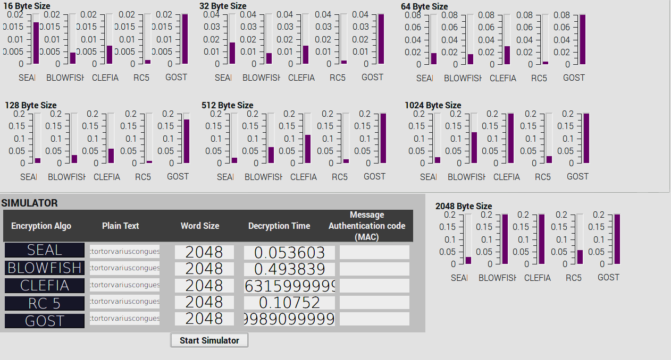
avT : = avT/10; // create average time for

avByteTime.push(avT)

IV The Data simulator Application
The performance evaluation of light weight encryption algorithm is achieved by implementing a simulator application. The simulator is a GUI based application program implement in QT with some widget such as push button ,bar graph, text editor etc. The GUI of the simulator used in evaluation of the algorithm is shown in figure 3.It uses a cyclic timer class that is used to stream the cipher text data to each algorithm and is activated using a small pushbutton” simulator”. The time used is decryption is depicted graphically and plain text stream with byte size and corresponding decryption time is depicted in textual mode through text editor widget.
The Algorithm is implemented by developing a simulator application. The simulator is a GUI based application program implement in QT with some widget such as push button ,bar graph, text editor etc. The GUI of the simulator used in evaluation of the algorithm is shown in figure 3.It uses a cyclic timer class that is used to stream the cipher text data to each algorithm and is activated using a small pushbutton” simulator”. The time used is decryption is depicted graphically and plain text stream with byte size and corresponding decryption time is depicted in textual mode through text editor widget

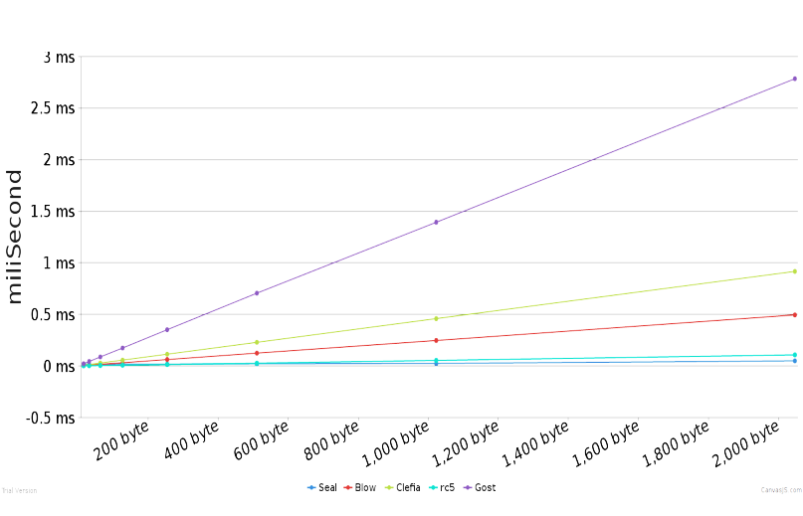
- Methodology of Performance Analysis
In order to evaluate the performance of the encryption algorithms two basic category of criteria was taken into account in our research work:-first one is total decryption time of the algorithms and other resource usage. The rational of taking into account of taking two different criteria as mentioned above is first the response time of the secured system should be minimal if it is trying to decrypt the data from the tag and other resource usage because RFID systems are by default memory and processing capability constrained devices. If the resource usage of the implemented system will be more than power requirement shall increase as most of the implementation in such IOT environment is constrained by low power requirement.
In order to evaluate and justify the selection of a particular light weight algorithm for implementation of the proposed secured RFID system a simulation run was carried out on two architecturally different systems. One of the system is a virtual machine based system which is fundamentally a X86 system on ubuntu OS and other is ARM processor based system (the actual target system) on sane ubuntu variation of OS.
- Performance on System 1
The details of system 1 which is a X86 based virtual machine is specified in table 2 below. Simulation run for system 1 was carried out as per schema described in section II , the graph of the decryption time versus the number of plain text byte size is shown in figure 3
Table 1:
System Aspect | Description
Architecture: | X86_64
Byte Order | Little Endian
CPU cores | 2
OS | Ubuntu Kernel version
Processor Class/Type | Intel 64/32 bit operation mode
CPU Max Frequency | 2594.112 MHz
CPU Min Frequency | 600
Table 2:
Byte Size | Seal | RC5 | BlowFish | GOST | Clefia
16 | 0.01663 | 0.0014 | 0.0044167 | 0.0218 | 0.0073124
32 | 0.022823 | 0.0014 | 0.0082187 | 0.0435 | 0.0143543
64 | 0.017062 | 0.0038 | 0.0159847 | 0.0879 | 0.0285208
128 | 0.017562 | 0.0072 | 0.0312505 | 0.173 | 0.0569948
256 | 0.018672 | 0.0138 | 0.0619169 | 0.3468 | 0.113901
512 | 0.020844 | 0.0271 | 0.123271 | 0.7020 | 0.22773
1024 | 0.025057 | 0.0538 | 0.248241 | 1.393 | 0.455627
2048 | 0.049750 | 0.1071 | 0.498565 | 2.784 | 0.916045

Figure 3
- Performance on System 2
The details of system 2 which is a ARM processor based v machine is specified in table 3 below.Simulation run for system 2 was carried out as per schema described in section II , the graph of the decryption time versus the number of plain text byte size is shown in figure 4
Table :3
System Aspect | Description
Architecture: | armv7l_32
Byte Order | Little Endian
CPU cores | 4
OS | Ubuntu Kernel version
Processor Class/Type | ARMv7 Processor rev 4 (v7l)
CPU Max Frequency | 1200 MHz
CPU Min Frequency | 600

Table 3
Byte Size | Seal | RC5 | BlowFish | GOST | Clefia
16 | 0.00752 | 0.0002 | 0.0011294 | 0.0079 | 0.0010932
32 | 0.00755 | 0.0003 | 0.0022178 | 0.0158 | 0.002112
64 | 0.00758 | 0.0006 | 0.0043844 | 0.0321 | 0.0041841
128 | 0.00764 | 0.0013 | 0.0086931 | 0.0631 | 0.0083578
256 | 0.00777 | 0.0052 | 0.0186982 | 0.1261 | 0.0168949
512 | 0.00803 | 0.0052 | 0.0361467 | 0.2611 | 0.0335489
1024 | 0.00854 | 0.0098 | 0.0712013 | 0.5018 | 0.0659058
2048 | 0.01601 | 0.0198 | 0.138285 | 0.9881 | 0.13337

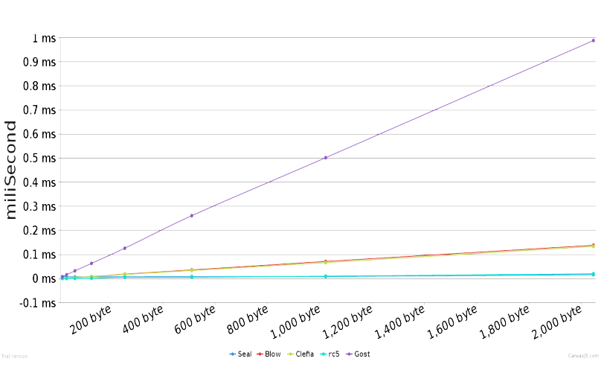

Main Thread
(Front End)
Read Write Thread
(Back End)

GUI
Write Signal
RF link configurations
T
A
G

String Format Input
Read/write
Unsigned long buffer conversion
Encrypt /Decrypt
Cipher Text to Hex format
Slot

- Performance Evaluation on memory usage
In order to evaluate the best real-time performance on memory usage of all five algorithms we used Valgrind(v3.15.0). Valgrind is a programming tool for memory debugging, memory leak detection and memory profiling. Basically, memory profiling for all five algorithms we measured memory space required for these algorithms at real-time.

REFERENCES

- Meola, Andrew. "How the Internet of Things will affect security & privacy." Business Insider. Business Insider, 19 Dec. 2016. Web. 28 Feb.2017.
- Stallings, William. Cryptography and network security: principles and practice. Upper Saddle River, NJ: Pearson/Prentice Hall, 2006.Print.
- "Lightweight Cryptography." CryptoLUX> Lightweight Cryptography. N.p., n.d. Web. 28 Feb.2017.
- Suzaki, T., Minematsu, K., Morioka, S., & Kobayashi, E. (2011). Twine: A lightweight, versatile block cipher. In ECRYPT Workshop on Lightweight Cryptography (pp. 146169).
- Wang, Y., Wu, W., & Yu, X. (2012). Biclique cryptanalysis of reduced-round piccolo block cipher. In Information Security Practice and Experience (pp. 337-352). Springer Berlin Heidelberg. pdf atspringer
- Minier, M. (2013). On the Security of Piccolo Lightweight Block Cipher against Related-Key Impossible Differentials. In Progress in Cryptology–INDOCRYPT 2013 (pp.308-318).
Springer International Publishing.pdf at springer.com
- Shibutani, K., Isobe, T., Hiwatari, H., Mitsuda, A., Akishita, T., &Shirai, T. (2011). Piccolo: an ultra-lightweight blockcipher. In Cryptographic Hardware and Embedded Systems–CHES 2011 (pp. 342-357). Springer Berlin Heidelberg. pdf atspringer
- Çoban, M., Karakoç, F., &Boztaş, Ö. (2012). Biclique cryptanalysis of TWINE. In Cryptology and Network Security (pp. 43-55). Springer Berlin Heidelberg. pdf ateprint.iacr.org
- Wang, Y., & Wu, W. (2014, January). Improved Multidimensional Zero-Correlation Linear Cryptanalysis and Applications to LBlock and TWINE. In Information Security and Privacy (pp. 1-16). Springer International Publishing. pdf atspringer.com
- Website of the International Standard Organization,http://www.iso.org/iso/iso_catalogue/catalogue
_tc/catalogue_detail.htm?csnumber=56552
- Li, Y., Wu, W., & Zhang, L. (2012). Improved integral attacks on reduced-round CLEFIA block cipher. In Information Security Applications (pp. 28-39). Springer Berlin Heidelberg. pdf atspringer
- Tezcan, C. (2010). The improbable differential attack: Cryptanalysis of reduced round CLEFIA. In Progress in Cryptology-INDOCRYPT 2010 (pp. 197-209). Springer Berlin Heidelberg.
- Shirai, T., Shibutani, K., Akishita, T., Moriai, S., & Iwata, T. (2007, January). The 128-bit blockcipher CLEFIA. In Fast software encryption (pp. 181-195). Springer Berlin Heidelberg.
- EmbeddedC."https://www.engineersgarage.com/tutorials/emebedded-c-language”
- "Memory Model - Handbook | mbed." Memory Model - Handbook | mbed. N.p., n.d.Web.
- "Benefits of C/C over Other Programming Languages." Invensis Blog. N.p., n.d.Web.
- "Memory Model - Handbook | mbed." Memory Model - Handbook | mbed. N.p., n.d.Web.
- "Mbed Compiler - Handbook | mbed." Mbed Compiler - Handbook | mbed. N.p., n.d.Web.
- "The mbed interface." The mbed interface - mbed OS 5 Handbook. N.p., n.d.Web.
- Suzaki, T., &Minematsu, K. (2010, January). Improving the generalizedFeistel.InFastSoftwareEncryption(pp.19-39).
Springer Berlin Heidelberg.pdf at eprint.iacr.org
- "SystemyRTiembedded."“http://www.ue.pwr.wroc.pl/systemy_rt/RTE6.pdf”N.p., n.d.Web.
- "ARM Cortex-M." Wikipedia. Wikimedia Foundation, n.d. Web.
- "Cortex-M4 Processor." Cortex-M4 Processor - ARM.N.p.,
n.d. Web.
- “http://www.st.com/en/microcontrollers/stm32-32-bit-arm-cortex-mcus.html?querycriteria=productId=SC1169” N.p.,
n.d. Web.
- "STM32F401RE."STM32F401RE - STM32 Dynamic Efficiency MCU, ARM Cortex-M4 core with DSP and FPU, up to 512 Kbytes Flash, 84 MHz CPU, Art Accelerator - STMicroelectronics.N.p.,n.d.Web. http://www.st.com/en/microcontrollers/stm32f401re.html.
- "ARM Information Center." ARM Information Center. N.p., n.d.Web. http://infocenter.arm.com/help/index.jsp?topic=%2Fcom.arm. doc.ddi0337h%2FBIIFBHIF.html.
- "Studying the Effects of Most Common Encryption Algorithms."(n.d.):n.pag.Web. http://www.iajet.org/iajet/iajet_files/vol.2/no.1/Studying%20t he%20Effects%20of%20Most%20Common%20Encryption% 20Algorithms.pdf.
- "Key size." Wikipedia. Wikimedia Foundation, n.d.Web.
- Kmarquet. "Kmarquet/bloc." GitHub. N.p., n.d. Web. https://github.com/kmarquet/bloc/tree/master.
- "Sony Corporation Global Headquarters." SONY. N.p., n.d.Web.http://www.sony.net/Products/cryptography/clefia/download/index.html.

